Major Project Report
On
Face Mask Detection
Submitted
in partial fulfillment of the requirements
for the award of the degree of
BACHELOR OF TECHNOLOGY
IN DEPARTMENT OFCOMPUTER SCIENCE & ENGINEERING


Supervisor: SubmittedBy:
Mr. Mukesh Choudhary Yuganter Sharma
Department of CSE Ajay Jangid
Hariom Singh
Dayana Singh
Parul Yadav

Department of Computer Science Engineering

RAJASTHAN INSTITUTE OF ENGINEERING AND TECHNOLOGY, JAIPUR.

INDEX
1.Acknowledgement
2.Abstract
3.Introduction
3.1Pipeline overview
3.2 Related Works
4. Face Detector Classifier Pipeline

4.1Dataset and Preprocessing
4.2 Classifier Baseline
4.3 Advanced Models
4.4 . Distillation
5. Object Detection Pipeline
5.1 Curating Dataset
5.2 YOLO v5
6. . Color Segmentation and Morphological Processing
6.1 MAP Decoder for Skin Segmentation
6.2 Results of Skin Segmentation
6.3 Hand and Arm Rejection
7. Template Matching
7.1 Grouping Correlation Peaks (Clustering)
8. The Algorithm Flow Chart
9. Final Results
10. Schemes That Didn’t Quite Make It: Fisher Linear Discriminant, Eigenfaces and
SVM.
10.1 Fisher’s Linear Discriminant
10.2 Eigenfaces

10.3 Support vector machines
11. conclusions.
12. refrences

ACKOWNLEDGEMENT

I cannot express enough thanks to RIET college committee
for their continued support and encouragement. I would like to thank my
supervisor Mr. MUKESH CHAUDHARY for his continuous support and
expert advice and encouragement throughout this difficult project to
his advice in report organisation and story writing. Also, for his continuous
encouragement to do this project. My completion of this project could not
have been accomplished without the support of my committee . I offer
my sincere appreciation for the learning opportunities and resources provided
by the RIET College. My heartfelt thanks
to my friends for your encouragement when the
times got rough are much appreciated and duly noted.

Abstract

In response to the ongoing COVID-19 pandemic, we
present a robust deep learning pipeline that is capable of
identifying correct and incorrect mask-wearing from realtime
video streams. To accomplish this goal, we devised
two separate approaches and evaluated their performance
and run-time efficiency. The first approach leverages a pretrained
face detector in combination with a mask-wearing
image classifier trained on a large-scale synthetic dataset.
The second approach utilizes a state-of-the-art object detection
network to perform localization and classification
of faces in one shot, fine-tuned on a small set of labeled
real-world images. The first pipeline achieved a test accuracy
of 99.97% on the synthetic dataset and maintained 6
FPS running on video data. The second pipeline achieved
a mAP(0.5) of 89% on real-world images while sustaining
52 FPS on video data. We have concluded that if a larger
dataset with bounding-box labels can be curated, this task
is best suited using object detection architectures such as
YOLO and SSD due to their superior inference speed and
satisfactory performance on key evaluation metrics.

1.Introduction

Face detection has been a fascinating problem for image processing researchers
during the last decade because of many important applications such as video face
recognition at airports and security check-points, digital image archiving, etc. In this project, we attempt to detect faces in a digital image using various techniques such ask in color segmentation, morphological processing, template matching, Fisher linear discriminant (FLD), eigen face decomposition, and support vector machines (SVM). We determined that the more complex classifiers did not work as well as expected due to the lack of large databases for training. Reasonable results were obtained with color segmentation, template matching at multiple scales, and clustering of correlation peaks. In 2020, the largest pandemic in recent history spread
through the world: COVID-19. As of May 1st, 2021, there have already been 152 million cases and 3 million deaths around the world . In many regions, those numbers are considerably under-counted . Beyond that, many parts of the world have slowed or stopped due to the human, economic, and social impacts of distancing and protection measures. For the purpose of the ongoing pandemic and predictions for future pandemics , this project seeks to create a mask detection system that is capable of recognizing whether people in surveillance-type video streams are correctly wearing their masks.

1.1. Pipeline Overview
Due to the real-time and real-world deployment constraints of such task, we decided to tackle this problem from two fronts - performance and efficiency. The first pipeline that focuses on accuracy uses a pre-trained face detector to extract faces from the frame, then passes the cropped faces to an image classifier. This mask-wearing classifier is trained on a large-scale synthetic dataset of 180,000 images divided into three classes: mask correctly worn, mask incorrectly worn, and no mask worn. We experimented with various models for this classifier, from traditional machine learning approaches such as random forest and Haarcascades to state-of-the-art computer vision architectures such as DenseNet and ResNet. The second pipeline leverages a real-time object detection architecture called YOLO, which is short for “You Only Look Once”. As implied by the name, this is an extremely fast and efficient model designed specifically for object localization and classification in real-time settings. We trained this model on a real-world dataset with face bounding box labels and mask-wearing classifications. Due to the time consuming process of bounding box annotation and the lack of methods to generate synthetic images, this dataset is comparatively small with 14,233 images.

1.2. Related Works
Projects with similar intent have been quite popular due to the ongoing pandemic. In the paper by Adnane Cabani and his colleagues from Universite de Haute-Alsace, a method was proposed to utilize haar-cascade based feature detectors to individually determine the presence of nose and and mouth from a detected face [7]. Their logic follows that no mask is worn if we can successfully detect a mouth from the face, mask is worn incorrectly if we can detect a nose by not a mouth, and mask is worn correctly if we can detect neither a nose nor a mouth. This approach is efficient and intuitive but has severe limitations - it can only process full-frontal faces and one can easily trick the detector by covering their mouth and nose with their hand. Another approach is proposed by Chandrika Deb in his Github project [12]. Similar to our first proposed pipeline, he utilizes a Caffe-based face detector in conjunction with a fine-tuned MobileNetV2 for mask-wearing classification. He was able to achieve a decent 0.93 f1-score on the classi-fier. Nevertheless, he used a very small dataset of 4095 images, which might not be representative of different ethnicities, genders, and types of facial coverings that the system might encounter in real-world settings. His data was also split into only two classes: with mask and without mask. So his model is incapable of detecting if someone is incorrectly wearing their mask (i.e having his or her mask below the nose). Lastly, the Github project by the Chinese company AIZOO Tech uses a object detection network for both face mask detection and classification, similar to our second proposed pipeline [10]. They used a lite version of SSD, which is short for Single-Shot Multi-box Detector [24], and achieved around 0.9 in precision and recall. This architecture is very similar to YOLO in both their underlying principal and their intended applications. However, the original SSD was published in 2015, which could be very outdated compare to the fifth iteration of YOLO that we are using, which is published in late 2020. Additionally, their dataset contains only 4095 labeled images - which could be too small for the reasons discussed previously.

2. Face Detector Classifier Pipeline
We need two networks for this pipeline - a face detector and a mask-wearing image classifier. Since face recognition has already been a well-defined and established task in computer vision with many existing solutions - there is no need
to reinvent the wheel. So for the face detector, we turn to an existing face recognition package built on-top of PyTorch called Facenet [14]. This package contains multiple pretrained deep learning face detectors and we will specifically
be using MTCNN, which is short for Multi-task Cascaded Convolutional Networks, due to its superior speed and efficiency [36]. As for the image classifier component that our project mainly focuses on, we will test various models from
traditional machine learning algorithms to state-of-the-art deep learning architectures. The experiment process and results will be explained in the next few sections.

2.1. Dataset and Preprocessing
For the image classification pipeline, we used the MaskedFace-Net dataset created by Universit´e de Haute- Alsace, which contains 133,784 artificially generated images of size 1024 by 2014, each containing a single human
face that are either correctly wearing a mask or incorrectly wearing a mask [6]. These images have been artificially generated by placing a blue medical mask over
images of uncovered frontal faces. To complete the third category where no mask is worn, we used 70,000 images from the Flickr Face Dataset develoepd by NVIDIA AI Lab [20]. So in summary, there are 67,049 instances in the correctly
masked category, 66,734 instances in the incorrectly masked category, and 70,000 instances in the no mask category. The first step in pre-processing was to resize all images from 1024x1024 to 128x128, in order to scale down the
original 38GB input. After the data was reduced to a more manageable size, we randomly split the whole dataset into train, validation, and test set with a ratio of 80:10:10. Lastly, we performed data augmentation for translational and scale
in-variance. The training images were first normalized then passed through a series of built-in PyTorch transformations including ColorJitter, Random Rotation, Random Resized- Crop, GaussianBlur, and RandomErasing. This was done
to minimize the overfitting of our model to training data.

2.2. Classifier Baseline
Before looking at advanced neural network architectures, we wanted to see whether simpler models would achieve high performance. Given that models tend to have a trade-off between performance and speed, starting with simpler models allowed us to get a baseline for performance Haar-based facial feature detection was one approach we tried, as this is a classic tried-and-true pattern
recognition algorithm for detecting facial features [33]. We also applied a random forest with a max depth of 2. As an ensemble method, random forests has great performance and prevents over fitting, while also having the advantage of being highly efficient. Given that mask wearing would be dependent on the pixels at the center of the image, it is possible that random forests would learn these feature combinations. And it appears they did - the random forest model achieved 94.33% accuracy, performing worst for predicting incorrectly masked folks at 87% and best for predicting correctly masked folks at 99% accuracy. It was also by far
our fastest model, performing 6951 instances per second on CPU. Our last base model was a vanilla CNN with two convolutional layers, each followed by a leaky ReLU activation function and a max pooling layer. These were followed by two linear layers, also using leaky ReLU as the activation function. This model achieved 98.55% test accuracy.

2.3. Advanced Models
In determining the best state-of-the-art deep learning architectures to use for transfer learning, we wanted to weigh accuracy versus network size. As a proxy for size, we consulted graphs that plotted accuracy against the number of operations and number of parameters. We looked for models in the upper-left quadrant with few parameters, as indicated by the bubble size. As a result, we picked DenseNet161 [18], MobileNet v2 [16], Inception v3 [32], and ResNet18 [15]. Here we will give a brief architecture highlight of the four networks that we chose. ResNet18 makes use of shortcut connections that are built upon residual blocks,
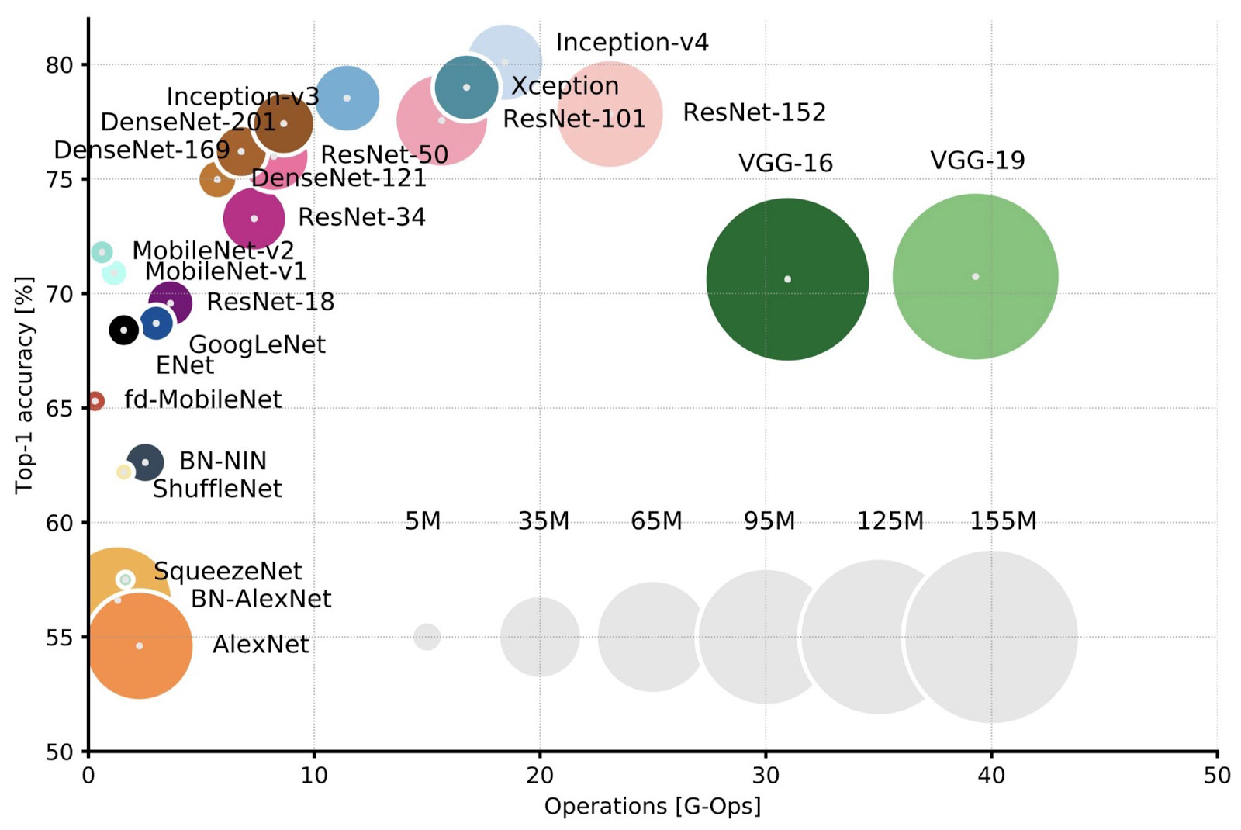

training about 11 million parameters. MobileNet v2 is a lightweight model that only has 3 million parameters. It uses depth-wise separable convolution and linear bottlenecks between the layers. For DenseNet, each layer receives feature maps from all preceding layers so that feature propagation is strengthened. The total number of parameters in this architecture is 29 million. InceptionNet v3 is a much wider network architecture that has about 24 million parameters. Multiple kernels of small and different sizes are implemented within the same layer. As shown in Table 2 summarizing the performance of
the advanced models, the test accuracies across the board are significantly higher than the base models, and they are all above the 99.5% accuracy line. The highest accuracy of 99.97% was achieved by DenseNet, and the second highest accuracy of 99.95% was obtained by MobileNet v2, followed by the 99.83% accuracy of InceptionNet v3, and the lowest accuracy of 99.75% was by ResNet18. While looking at the inference speed of these models, ResNet was the fastest, which was able to inference 680 instances per second on Tesla V100, and DenseNet was the slowest mode, which was capable of inferring only 301 instances per second.
The trade-off between accuracy and speed was noticeable here.

2.4. Distillation
As our use case required model speed as well as performance, we used the technique of knowledge distillation to see if we could achieve comparable performance with a smaller model. Using our initial CNN model as the student, we performed vanilla distillation using our highestperforming model, DenseNet (99.97% test accuracy), as the teacher network. The result was a CNN with 99.85% test accuracy and the best inference speed out of all our advanced models - 775.35 instances per second on a Tesla V100. The CNN had 15% as many parameters as DenseNet. Given the small size, fast computation, and high accuracy, the CNN after distillation met our project goals and would be a good model to use going forward.

3.Object Detection Pipeline

3.1. Curating Dataset
To train or fine-tune an object detection network like SSD and YOLO, we need a dataset with ground-truth bounding box labels in addition to the mask-wearing classifications. This makes gathering a large dataset very challenging as the annotation process is time-consuming and there are no straight-forward methods to generate synthetic data like the first pipeline. Luckily we were able to combine
two bounding-box-labeled datasets on Kaggle - one from Wobot Intelligence [2] and another from Andrew Moranhao [25]. However we noticed that the “no mask worn” class is severely under-represented in both of the datasets.
3.2. YOLO v5
For
object detection architecture, we decided to use The fifth iteration of YOLO, which is short for You Only Look Once [19]. The original paper by Redmon et. al was published in May 2016, and they were the first object detection network to combine the problem of object localization (bounding boxes) and classification in one end-to-end differentiable network [30]. The underlying principle is that
YOLO treats detection as a regression problem - it divides the image into a grid, and for each grid cell it simultaneously produce boxing box confidence and class probability. The model then aggregates those results to produce the final bounding box output and classification. This architecture is known for its performance and efficiency on real-time video data, so it is naturally a good fit for our task. Over the years, there have been multiple iterations and improvements over the original YOLO architectures. This leads us to the fifth version, YOLO v5, developed by the company Ultralytics. This latest iteration utilizes Cross Stage Partial Network (CSPNet) [34] as the model backbone and Path Aggregation Network (PANet) [23] as the neck for feature aggregation (see Figure 3). These improvements have led to better feature extraction and a significant boost in the mean averaged precision score.
4. Color Segmentation and Morphological Processing

The first step in our face detection algorithm was to segment regions in the image
based on skin color. It is important to decide which color space to operate on in order to effectively segment skin color of different shades and under a variety of lighting conditions. While the images are conventionally represented in the RGB domain for display, the color and intensity components are correlated. Therefore, using the RGB color space would require some pre-processing [1] in order to reduce the effects of unwanted variations in intensity. On the other hand, both the YCbCr and HSV color models separate intensity and color information of the image effectively. Various studies have shown that the skin color regions are highly correlated in their hue and saturation channels (HSV model) or chrominance channel (YCbCr model). The information of different shades is usually present only in the intensity channel (Y or V), and it captures variations in the lighting conditions. Therefore, CbCr or HS channels are used in skin color segmentation. In this project, we decided to implement the MAP rule to achieve skin color segmentation. This technique requires determination of probability maps based on the ground truth data. The YCbCr representation is convenient for this approach because the color levels are discrete in this domain.

4.1 MAP Decoder for Skin Segmentation

A variation of the maximum a posteriori (MAP) probability decoder[3] is used to
segregate non-skin pixels (NS) from the skin pixels (S). We define the decoder as
follows:
D(I(x,y)) = 1 if P(I(x,y) | S)P(S) > P(I(x,y) | NS)P(NS)………………(1)
= 0 other wise, where
P(S) is the probability of skin pixels in a typical image
P(NS) is the probability of non-skin pixels in a typical image
P(I(x,y) | S) is the a priori probability distributionof pixels in skin region
P(I(x,y) | NS) is the a priori probability distribution of the pixels in non-skin
Region I(x,y) = [Cr(x,y) Cb(x,y)], a vector of the two chrominance components
Using the ground truth data from the training images 1 through 4, probability
maps of the chrominance components for skin and non-skin pixels are determined. the probability maps of P(I(x,y) | S) and P(I(x,y) | NS) are plotted. The MAP rule exploits the peaks of the two distributions and the distance between them. An additional advantage of using the MAP decoder is that the decision boundary between skin and non-skin regions does not need be linear We modified decision rule to include a threshold to reduce the error of misclassifying skin regions as non-skin regions.
D(I(x,y)) = 1 if P(I(x,y) | S)P(S) > T*P(I(x,y) | NS)P(NS)………………(2)
The threshold T is determined heuristically for the best performance in skin
segmentation.

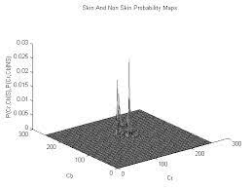
Probability maps of skin and non-skin regions
The two peaks correspond to skin and non-skin (larger peak) pixels.
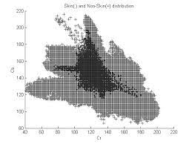
Distribution of skin and non-skin pixels
Cr and Cb have been translated from [-128:127] to [0:256].Decision boundary between skin and non-skin pixels is non-linear.
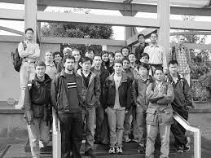
Training_5.jpg from the training data set

4.2 Results of Skin Segmentation

Once the probability maps are obtained, the decision rule (2) is applied to each pixel of the image to classify it either as a skin or non-skin pixel. In order to speed up the process, the original image is sub sampled by a factor of 4 before the skin segmentation routine is applied. Figures 3 and 4 show the results of skin segmentation. After skin segmentation, the image mask is up-sampled back to the original image size for further processing.
As we can see in figure 4, most of the face regions pass through the skin segmentation routine along with some background noise. We now filter out the background noise by rejecting connected region (50x50 square pixels) that are smaller than a typical face region. After the routine, features such as the eyes appear as holes in the face objects. We will make use of these features in the next step of our algorithm, which is template matching. In order to recover these features, a closing operation is performed using a structure element of size 5x5,
followed by hole removal. The result of these operation.
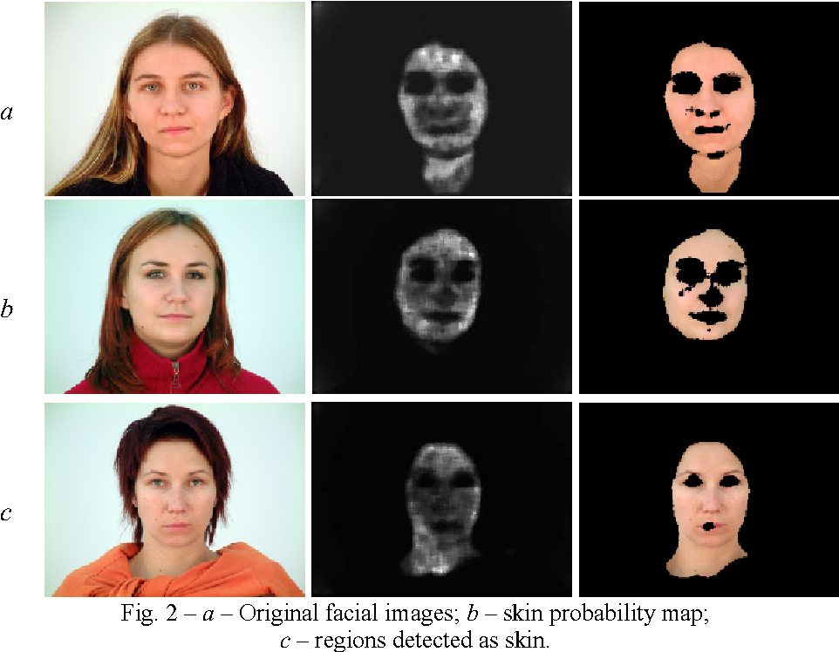

4.3. Hand and Arm Rejection

After blob rejection and closing, several non-face regions remained in the image.
These regions included arms, hands, and legs. These areas would present problems in the template matching because they cause high correlation peaks. In order to reject these regions, a method based on standard deviations was devised. The general idea was to make reasonable assumptions about the shape, size, and location of possible faces in the image, and reject all blobs that did not fit these assumptions. Each blob was first characterized by the maximum ratio of standard deviations perpendicular directions (smax/smin). This ratio is the maximum over all possible orientations. For example, smax/smin could be obtained by rotating a blob by all angles about its centroid and finding the maximum ratio sy/sx over all angles of rotation. smax/smin is the same for any shape regardless of its orientation, and indicates how long a shape is. For instance, a circle has smax/smin = 1, while this same quantity is larger than 1 for an ellipse. In order to reject arms, only blobs with relatively small smax/smin were retained. The choice of threshold here was difficult because, although a face has a
standard deviation ratio just above one, several faces grouped together as a blob can have a standard deviation ratio that is much higher. Using a combination of size, location, and the aforementioned smax/smin to characterize the blobs, we ensured that the chance of losing a face in this process was minimized. Finally, small blobs corresponding to hands that appeared relatively low in the image were rejected.
a) Mask before smax/smin based rejection
b) Mask after smax/smin based rejection and location-dependent thresholding

5. Template Matching
After color segmentation, blob rejection, closing, and hole filling, template matching was used to isolate faces from non-faces. The template matching was performed in the luminance domain, using the FFT. Because the template size was small compared to the image size, using circular convolution instead of linear convolution introduced negligible error. The initial template was an average of all face regions in the image. From the reference data, the centroid of each face region was computed, and a rectangular region of pixels about the centroid was extracted for each face region. These regions were then averaged and mean subtracted. Regions in the rectangular template deemed to be background were manually set to zero after mean subtraction so that they would not affect the correlation result. This template performed reasonably well, and did not require multiresolution template matching, since faces of all scales appeared in the template. A disadvantage of this template was
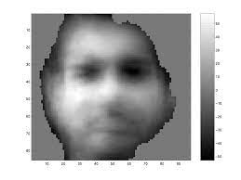

at features were not sharply defined. Ascan be seen below, the first template was not “face -like” in appearance. resizing. (Not used in final version) The final method of template creation was to resample each face region to the same size before averaging. This caused the features in the different faces to align better when the averaging operation was performed. As can be seen below, this template looks more “face-like” in appearance. For this method, because every face used in taking the average was resampled to the same scale, multiresolution template matching was used. A symmetric template (Figure 8a) was obtained by including the mirror image of every face region in the averaging process. The symmetric template yielded sharp correlation peaks near the center of most faces, and performed better than an otherwise identical non-symmetric template. This may seem somewhat surprising since the symmetric template does not incorporate luminance differences due to lighting from one side. However, the symmetric template, while losing information about the lighting, performs better in isolating symmetric regions. Furthermore, the lighting was not very dramatic for the test images. (Note: the symmetric template background is not zero. Reasonable results were obtained using this template, so the background was not set to zero.) In addition to the symmetric template, a downsampled, non-symmetric, partial template (Figure 8b) was used to capture information about smaller and partially obscured faces in the image. The template size was chosen to match faces near the back of the test images. Because larger faces obscure the mouth and chin of many smaller
faces in the test set, the smaller template was chosen to match only the eyes and forehead.
Since the smaller template was not symmetric, its lighting matched the lighting in the test image.

5.1 Grouping Correlation Peaks (Clustering)
In order to group peaks, information from the color based segmentation mask was used. If the centers of two peaks were sufficiently close together and a line between the centers did not pass through any non-skin regions, then the two peaks were grouped together as belonging to the same face. Various heuristic techniques based on morphology of the skin regions were also used in the grouping process. The final face locations were the cluster centroids.

6. The Algorithm Flow Chart

Read Image

Convert RGB to YCbCr

Skin Color
Segmentation

Binary Mask Processing
(Morphological Operators)

Multi-Resolution Template Matching

Clustering Detected Face

Detected Face

7. Final Results

The final results for the seven test images are shown below.
Image 1 2 3 4 5 6 7
Score 20 22 24 22 24 24 21
Total 21 24 25 24 24 24 22

8. Schemes That Didn’t Quite Make It: Fisher Linear Discriminant, Eigenfaces and SVM

Apart from connected pixel analysis a few other techniques were tested to reject
false positives like hands, arms and legs.

8.1 Fisher’s Linear Discriminant
Fisher’s linear discriminant technique is a popular scheme to segregate patterns
that are linearly separable. It is based on projecting the pattern vectors from a large dimensional space onto a line thereby reducing the N-d classification problem to a 1-d classification problem. A database of 500 samples each of 60x60 face images and non-face images were created and subsampled to 24x24. The samples were generated by extracting windows from the original data set. The non-face images largely comprised regions from the images that showed up as faces post template matching. The linear discriminant is computed as follows [4]:
S1 = å (X –M1)(X – M1)T
S2 = å (X –M2)(X – M2)T
Sw = S1 + S2
M1 = mean(X)
M2 = mean(Y)
W = Sw
-1(M1 – M2)
The X’s are the face vectors, the Y’s are the non-face vectors and Sw is the within Scatter Matrix. S1 and S2 are correlation matrices for the two classes of vectors and W is the fisher’s linear discriminant. If the projected component of the object on Fisher’s linear discriminant (WT X) exceeds a certain threshold then the object is classified as a face. Otherwise it is rejected. This technique had a very poor performance in rejection of false positives possibly because detected non-face regions and face regions are not linearly separable.

8.2 Eigenfaces
A variation of template matching was also attempted in order to reject the false
positives. All faces were extracted using the provided ground truth data on the first 4 training images. These face images were then interpolated onto a uniform 95x85 cartesian grid. Using Sirovich and Kirby procedure [5] the first 94 eigenimages were computed. Ten of these eigenfaces corresponding to the 10 largest eigenvalues captured most of the energy and hence were used in the analysis. This process was repeated at two more scales of 124x111 and 67x59. Two different schemes were attempted, to reject non-face objects obtained after
template matching. The first one was to compute the total energy contained along the first ten eigenvectors and reject objects that were below a certain threshold. The other scheme was to maintain a database of face and non -face projections and use the nearest neighbor criteria in rejecting false positives. Both schemes gave results similar to template matching and at an increased computational cost and hence were discarded.

8.3 Support Vector Machines (SVM)
A support vector machine is a learning computer algorithm used in pattern classification problems. The principle behind SVM is to find an optimal hyperplane such that the two different regions are separated as far as po ssible to minimize errors. In our face recognition application, we want to construct a function f(x) such that f(x) = 1 for a face region and f(x) = -1 for a non-face region. Therefore, f(x) can be constructed in the form f(x) = 􀀀 _ i * ai * k(x, xi) + b. We input training samples in the form of {xi, yi} where the xi’s are the training input vectors and the yi’s are input values taking on either 1 or –1. The k(x, xi) function is called a kernel. There are different types of kernels ranging from the linear function (dot product of x and xi), a polynomial function, and the radial basis function involving Gaussian distributions. Basically, the algorithm calculates the scalar values ai’s and b based on the training samples given and thus the xi’s associated with the nonzero ai’s are called support vectors.
In our project, we implemented a SVM with a radial basis function (RBF) kernel.
The function f(x) has the has the form f(x) = 􀀀 􀀀 i * G(x; ci_ _ i2) + b where G is the ith Gaussian basis function to produce a scalar output. Based on the training samples and the number of basis functions that are supplied, the SVM calculates all the parameters in f(x). To train the SVM, we generated 470 face regions and 500 non -face regions from the first 4 training pictures, each of size 49x55 pixels. We chose various basis function numbers of 1, 8, 16, 20, and 36. After the parameters of f(x) are generated, we then tested it out in our program after skin segmentation and template matching. We hoped that this rejection method would further eliminate all non-face regions to produce an improved face recognition result. However, after implementing and adjusting different factors such as size of training regions and number of training samples, we did not achieve satisfactory results. This is because the SVM produced decision regions that are too tightly bound to the training face samples and were not able to classify the faces in the other 3 training pictures. We considered generating more training samples, but we realized that the time it would require to train the SVM would be prohibitively long. Since we had already achieved adequate results from skin segmentation and template matching, we decided that including the SVM in the program would only slow down our runtime and would not produce noticeable improvements.

9. Conclusions

Because large databases of face and non-face regions were not available, our implementations of techniques such as FLD and SVM worked about as well as template matching. In addition, eigenface methods yielded no noticeable improvement over template matching. Ideally, neural networks, FLD, SVM, or MRC (maximal rejection classification) could be used after color segmentation and template matching to reject the false positives, non-faces classified as faces. However, the absence of large databases to train these classifiers degraded their performance. Instead of these techniques we used a highly heuristic and scale-specific method of clustering correlation peaks.

10. References

1. M.Hunke and A. Waibel, “Face Locating And Tracking for Human Computer
Interaction”,in Proc. Conf. Signals Systems and Computers, Nov 1994, vol2 pp 1277-1281. Circuit and Systems for Video Technology, 2. Abbas El Gamal, “Introduction To Statistical Signal Processing”, Lecture Notes.
3. Richard Duda, Peter Hart and David Stork, “Pattern Classification”, 2nd ed., John
Wiley and Sons.
4. Sirovich, L. and Kirby, M.: 1987, Low dimensional procedure for the characterization
of human faces, J. Opt. Soc. Am. A 4, 519–524.
5. Gender classification with support vector machines,
www.merl.com/reports/docs/TR2000-01.pdf
6. Support Vector Machnie(SVM)

